Join DataFrames along Rows (Join Rows)

Write a Pandas program to join the two given dataframes along rows and assign all data.

**Test Data:**

student_data1:

student_id name marks

0 S1 Danniella Fenton 200

1 S2 Ryder Storey 210

2 S3 Bryce Jensen 190

3 S4 Ed Bernal 222

4 S5 Kwame Morin 199

student_data2:

student_id name marks

0 S4 Scarlette Fisher 201

1 S5 Carla Williamson 200

2 S6 Dante Morse 198

3 S7 Kaiser William 219

4 S8 Madeeha Preston 201

import pandas as pd

student_data1 = pd.DataFrame({

'student_id': ['S1', 'S2', 'S3', 'S4', 'S5'],

'name': ['Danniella Fenton', 'Ryder Storey', 'Bryce Jensen', 'Ed Bernal', 'Kwame Morin'],

'marks': [200, 210, 190, 222, 199]})

student_data2 = pd.DataFrame({

'student_id': ['S4', 'S5', 'S6', 'S7', 'S8'],

'name': ['Scarlette Fisher', 'Carla Williamson', 'Dante Morse', 'Kaiser William', 'Madeeha Preston'],

'marks': [201, 200, 198, 219, 201]})

print("Original DataFrames:")

print(student_data1)

print("-------------------------------------")

print(student_data2)

print("\nJoin the said two dataframes along rows:")

result_data = pd.concat([student_data1, student_data2])

print(result_data)

OUTPUT

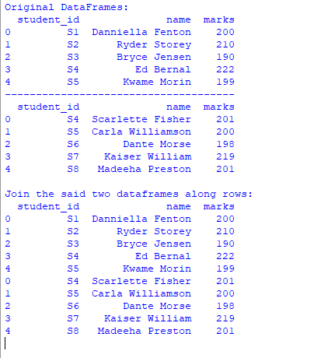

Join DataFrames along Columns (Join Columns)

Write a Pandas program to join the two given dataframes along columns and assign all data.

**Test Data:**

student_data1:

student_id name marks

0 S1 Danniella Fenton 200

1 S2 Ryder Storey 210

2 S3 Bryce Jensen 190

3 S4 Ed Bernal 222

4 S5 Kwame Morin 199

student_data2:

student_id name marks

0 S4 Scarlette Fisher 201

1 S5 Carla Williamson 200

2 S6 Dante Morse 198

3 S7 Kaiser William 219

4 S8 Madeeha Preston 201

import pandas as pd

student_data1 = pd.DataFrame({

'student_id': ['S1', 'S2', 'S3', 'S4', 'S5'],

'name': ['Danniella Fenton', 'Ryder Storey', 'Bryce Jensen', 'Ed Bernal', 'Kwame Morin'],

'marks': [200, 210, 190, 222, 199]})

student_data2 = pd.DataFrame({

'student_id': ['S4', 'S5', 'S6', 'S7', 'S8'],

'name': ['Scarlette Fisher', 'Carla Williamson', 'Dante Morse', 'Kaiser William', 'Madeeha Preston'],

'marks': [201, 200, 198, 219, 201]})

print("Original DataFrames:")

print(student_data1)

print("-------------------------------------")

print(student_data2)

print("\nJoin the said two dataframes along columns:")

result_data = pd.concat([student_data1, student_data2], axis = 1)

print(result_data)

OUTPUT

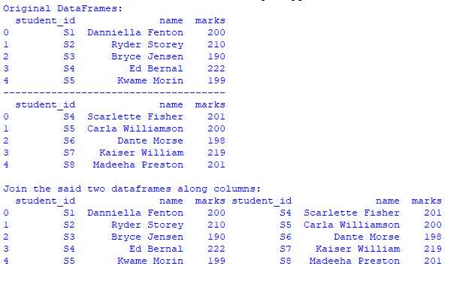

Join Rows and Merge with Another DataFrame

Write a Pandas program to join the two given dataframes along rows and merge with another dataframe along the common column id.

**Test Data:**

student_data1:

student_id name marks

0 S1 Danniella Fenton 200

1 S2 Ryder Storey 210

2 S3 Bryce Jensen 190

3 S4 Ed Bernal 222

4 S5 Kwame Morin 199

student_data2:

student_id name marks

0 S4 Scarlette Fisher 201

1 S5 Carla Williamson 200

2 S6 Dante Morse 198

3 S7 Kaiser William 219

4 S8 Madeeha Preston 201

exam_data:

student_id exam_id

0 S1 23

1 S2 45

2 S3 12

3 S4 67

4 S5 21

5 S7 55

6 S8 33

7 S9 14

8 S10 56

9 S11 83

10 S12 88

11 S13 12

import pandas as pd

student_data1 = pd.DataFrame({

'student_id': ['S1', 'S2', 'S3', 'S4', 'S5'],

'name': ['Danniella Fenton', 'Ryder Storey', 'Bryce Jensen', 'Ed Bernal', 'Kwame Morin'],

'marks': [200, 210, 190, 222, 199]})

student_data2 = pd.DataFrame({

'student_id': ['S4', 'S5', 'S6', 'S7', 'S8'],

'name': ['Scarlette Fisher', 'Carla Williamson', 'Dante Morse', 'Kaiser William', 'Madeeha Preston'],

'marks': [201, 200, 198, 219, 201]})

exam_data = pd.DataFrame({

'student_id': ['S1', 'S2', 'S3', 'S4', 'S5', 'S7', 'S8', 'S9', 'S10', 'S11', 'S12', 'S13'],

'exam_id': [23, 45, 12, 67, 21, 55, 33, 14, 56, 83, 88, 12]})

print("Original DataFrames:")

print(student_data1)

print(student_data2)

print(exam_data)

print("\nJoin first two said dataframes along rows:")

result_data = pd.concat([student_data1, student_data2])

print(result_data)

print("\nNow join the said result_data and df_exam_data along student_id:")

final_merged_data = pd.merge(result_data, exam_data, on='student_id')

print(final_merged_data)

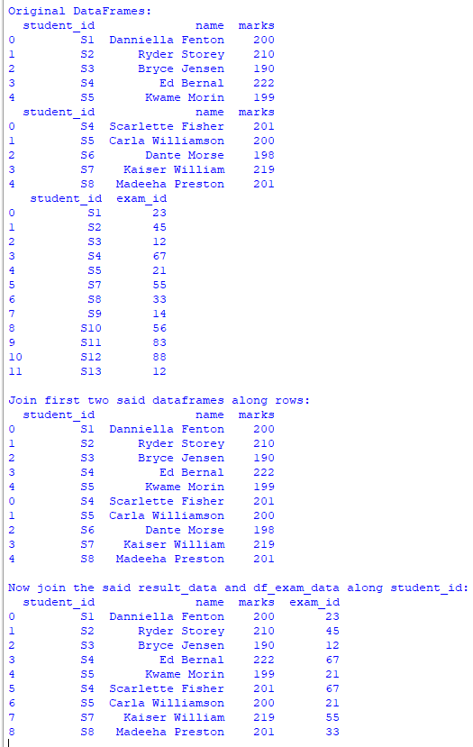

**Pandas - Render DataFrame as HTML Table**

You can convert a Pandas DataFrame into an HTML table to represent it on web pages.

To render a Pandas DataFrame as an HTML Table, use the pandas.DataFrame.to_html() method.

The entire DataFrame is converted into a <table> HTML element, with column names wrapped in the <thead> (table head) element. Each row of the DataFrame is then represented as a <tr> (table row) in the HTML table.

### 1. Render DataFrame as HTML Table

import pandas as pd

# Create DataFrame

df_marks = pd.DataFrame({'name': ['Somu', 'Kiku', 'Amol', 'Lini'],

'physics': [68, 74, 77, 78],

'chemistry': [84, 56, 73, 69],

'algebra': [78, 88, 82, 87]})

# Render DataFrame as HTML

html = df_marks.to_html()

print(html)

#### Explanation:

1. The DataFrame is created using a dictionary containing student names and their marks in various subjects.
2. The to_html() method is called on the DataFrame, converting it into an HTML table.
3. The resulting HTML table includes the column names as table headers and each row of data as a table row.

#### Output

<table border="1" class="dataframe">

<thead>

<tr style="text-align: right;">

<th></th>

<th>name</th>

<th>physics</th>

<th>chemistry</th>

<th>algebra</th>

</tr>

</thead>

<tbody>

<tr>

<th>0</th>

<td>Somu</td>

<td>68</td>

<td>84</td>

<td>78</td>

</tr>

<tr>

<th>1</th>

<td>Kiku</td>

<td>74</td>

<td>56</td>

<td>88</td>

</tr>

<tr>

<th>2</th>

<td>Amol</td>

<td>77</td>

<td>73</td>

<td>82</td>

</tr>

<tr>

<th>3</th>

<td>Lini</td>

<td>78</td>

<td>69</td>

<td>87</td>

</tr>

</tbody>

</table>

## Concat Pandas DataFrames with Inner Join

You can inner join two DataFrames during concatenation which results in the intersection of the two DataFrames.

### Syntax

The syntax of concat() function to inner join is given below.

pd.concat([df1, df2], axis=1, join='inner')

Inner join results in a DataFrame that has intersection along the given axis to the concatenate function.

### 1. Inner join DataFrames along an axis

In this example, we shall take two DataFrames and find their inner join along axis=1.

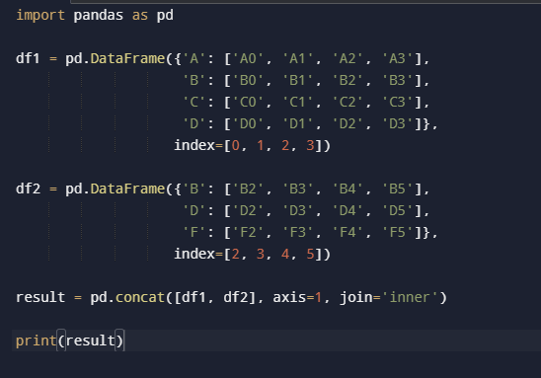



### 2. Inner join DataFrames along axis=0

In this example, we shall try the inner join of DataFrames along a different axis from that of the previous example.

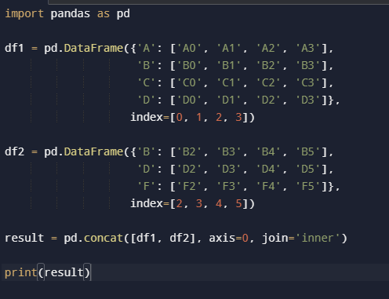



### 3. Inner join more than two DataFrames using concat()

In this example, we shall take more than two DataFrames, which is three, and find the inner join of these DataFrames along an axis.

